A mini Project Report on
CALCULATOR USING WEB TECHNOLOGY
Dissertation submitted
in partial fulfillment of the requirement
for the award of the degree of
Bachelor of Engineering
In
COMPUTER SCIENCE & ENGINEERING
SUMMAYA EREEZA
Roll No:245219733020
KAVALI SRAVANI
Roll No: 245219733009
KONNE RAMYA
Roll No:245219733305

Under the Guidance of
Mrs. B.Shobini M. Tech
Head of the Department, C.S.E, SITS.

DEPARTMENT OF COMPUTER SCIENCE &ENGINEERING
SWATHI INSTITUTE OF TECHNOLOGY & SCIENCES
(Affillated To Osmania University, Hyderabad)
2021-2022
SWATHI INSTITUTE OF TECHNOLOGY & SCIENCES
(Affillated To Osmania University, Hyderabad)
2021-2022
DEPARTMENT OF COMPUTER SCIENCE &ENGINEERING
DECLARATION
SUMMAYA EREEZA bearing Roll No:245219733020, KAVALI SRAVANI bearing Roll No:245219733009 , KONNE RAMYA bearing Roll No:245219733305
Hereby certify that the dissertation entitled, “CALCULATOR USING WEB TECHNOLOGY” carried out under the guidance of Mrs.B.Shobini, Head of the Department is submitted to Osmania University, Hyderabad in partial fulfillment of the award of the degree of Bachelor of Engineering in Computer Science & Engineering. This is a record of bonafide work carried out by me and the results embodied in this dissertation have not been reproduced or copied from any source. The results embodied in this dissertation have not been submitted to any other University or Institute for the award of any other degree.

DATE: SUMMAYA EREEZA
Roll No: 245219733020
KAVALI SRAVANI
Roll No: 245219733009
KONNE RAMYA
Roll No: 245219733305
SWATHI INSTITUTE OF TECHNOLOGY & SCIENCES
(Affillated To Osmania University, Hyderabad)
2021-2022
DEPARTMENT OF COMPUTER SCIENCE &ENGINEERING
CERTIFICATE
This is to certify that the dissertation entitled “CALCULATOR USING WEB TECHNOLOGY “, being submitted by, SUMMAYA EREEZA bearing Roll No:245219733020, KAVALI SRAVANI bearing Roll No:245219733009 , KONNE RAMYA bearing Roll No:245219733305,to Osmania University , Hyderabad in partial fulfillment of the requirements for the award of the degree of Bachelor of the Engineering in Computer Science & Engineering, is a record of bonafide work carried out by him. The results of investigations enclosed in this report have been verified and found satisfactory. The results embodied in this dissertation have not been submitted to any other University or institute for the award of any other degree or diploma.

Internal Guide HOD
Mrs. B.Shobini, M.Tech
Head of the department,
CSE, SITS

TABLE OF CONTENT
Contents Page no
DECLARATION 02
CERTIFICATE 03
ABSTRACT 05
Chapter 1 Problem Analysis & Project Planning 06
1.1 | Introduction 06
1.2 | Scope 06
Chapter 2 Literature view on
Voice Recoginition Calculator 07-08
2.1 Historical View 07

2.2 Calculator Theory 08
Chapter 3 Features of Voice Recoginition Calculator 09-11
Chapter 4 TOOLS AND TECHNOLOGIES 12-14
4.1 HTML/HTML5 12
4.2 CSS3 12-13
4.2 JAVA SCRIPT 13-14
Chapter 5 Source code 15-22
Chapter 6 Screen Shots 23-25
Chapter 7 Conclusion 26

Abstract

The voice activated calculator is a speaker-independent system that is used to perform basic mathematical operations. It recognizes the isolated spoken digits from 0 to 9, and other words like plus, minus, times, equal and clear. It then performs the respective arithmetic operations, and displays the final answer on an LCD display.
Keywords: PIC Microcontroller, Voice Recognition Calculator, LCD display and Speech detection and Recognition

Chapter 1 Problem Analysis & Project Planning

1.1 Introduction
Speaker-independent voice recognition systems have a very strong probability of becoming a necessity in the workplace in the future. Such systems would be able to improve productivity and would be more convenient to use. The idea of a hardware that can recognize any person's voice without the training time involved in currently employed systems is a very promising one, and possibly a marketable one too. At its most basic level speech recognition allows the user to perform parallel tasks, (i.e. hands and eyes are busy elsewhere) while continuing to work with the computer or appliance. The addition of an audio function to the device can be Audio added to the device can be a medium to provide information on visual mathematical phenomena, and to enhance learning and cognition. However, more knowledge is needed about how cognitive processes are activated in order to comprehend an auditory text, not least a mathematical text, and about effective navigational strategies using text-to-speech technologies. The results of our review show that digital textbooks and aural feedback have become essential in learning technologies for students with visual impairments, as audio was applied in 9 of the 13 studies
1.2 Scope
Calculators have a wide scope of applications, being useful in many fields like science, technology, accounting, marketing, education, finances, etc, etc. Their accessibility depends on the user understanding basic mathematical concepts such as addition, subtraction, multiplication, division, etc. Scientific calculators require a more advanced level of understanding from the user for their scientific functions.
Calculators are ridiculously easy to obtain as they are available in hardware form in any supply store or supermarket, and also in software form in computers, smartphones, tablets, etc. An interesting form factor is the “calculator watch” which combines a calculator and a wrist watch into a single device.
Chapter 2 Literature view oF Voice Recoginition Calculator

2.1Historical View
The idea of speech recognition was come in 1920. In 1920 first time this technique was implemented on Radio(toy) . In 1939 at bells lab speech synthesis machine was developed which can artificially listen and recognize the human speech. In 1950 the speech recognition system investigates spectral resonances during the vowel region of each utterance which can extract from output signal of an analog filter box and logic circuit. In 1960’s Japanese laborites entering recognition arena and they built special purpose hardware which can recognize only vowels. In 1970’s speech recognition technology was focused on isolated words or discrete utterance recognition using linear predictive coding technique . In 1980’s this problem has been solved and robust system which recognize the string of words. In 1990’s many innovations took place in the field of pattern recognition. Main objective was to achieve least recognition error and provide the best fitting of distribution function to given data. In 2000’s the adaptive learning techniques has been develop for artificial learning of speech. In 2005 some improvements was developed in speech recognition system as continuous speech recognition and performance improvements on large scale speech data base . This project explored a newly developed computer-based voice input, speech output (VISO) calculator. The time they took to complete assessments and the average number of attempts per problem were recorded when they used the VISO calculator and their typical individualized method of calculation. The results indicated that the time to complete assessments and the average number of attempts per problem decreased as the students continued to use the VISO calculator. Students reported positive perceptions of the calculator, particularly noting the independence it provided as compared to their typical means of calculation. Implications for practice, limitations of the study, and future research directions are discussed.

2.2 Calculator Theory
Calc is the name of the spreadsheet program used in OpenOffice. A calculator is an electronic hardware device or software capable of performing mathematical calculations, such as addition, multiplication, subtraction, or division. The Casio Computer Company developed the first electronic calculator in 1957. Since then, calculators have come in many sizes and are built into most operating systems on computers, smartphones, and tablets. The picture is an example of the Calculator program included in every version of Microsoft Windows.
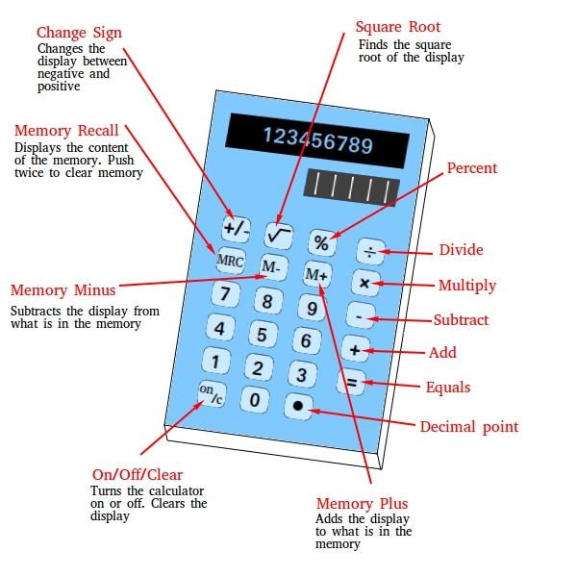

Chapter 3 : Features Voice recognition Calculator

Calculator Features
Voice Calculator is one of the best way to calculate for using the voice-activated calculator and other calculators. This application fulfils the basic needs of life for working people, for students of engineering, teachers, for clerical work and for other such purposes like a carpenter on shop markets does a very fast calculation on a daily basis. Users can view the history of all types of calculators that they have recently used in this application.
Features of Voice Calculator
# Users can calculate multiple operations through the Voice input system.
# Users can do a manual calculation by simply using a simple calculator.
Voice Calculator is a simple and user-friendly Application that ultimately makes your work easier. This application requires an internet connection. Users have to just speak their queries and the voice calculator will give instant results of those queries. Users can execute simple and complicated calculations through speech recognition Technology as per their requirements. Users have to just keep in mind that they have to speak all the equations at the same time as per their requirements.
How to use this application?
Step 1. Click on the Tap button to Speak.
Step 2. Just speak your queries like,
# To calculate addition (+) just speak,
Like, 8+1, say: eight plus one.
# To calculate subtraction (-) just speak,
Like, 5-1, say five minus one.
# To calculate multiplication (*) just speak,
Like, 6*3 say: six multiplied by three.
# To calculate division (/) just speak,
Like, 7/3 say: seven divided by three.
Users have to just speak their queries like addition, subtraction, multiplication, and Division, etc
Step 3. Tap to calculate to get the result.
Step 4. Tap on the speaker to hear the result.
* for better results use a microphone.
Users can do Simple calculations like addition, subtraction and many more multiple operations that can be done by this application.
Users can share this link to different social media networks. So, they can use and share it with their friends and family members and also tell them to and be a part of the "Voice Calculator” family.

- How do you use the smart voice calculator?
Step 1: Click on tap to say the values.

Step 2: Give instructions for calculations.

Step 3: Tap on Speaker button to get the results.

.

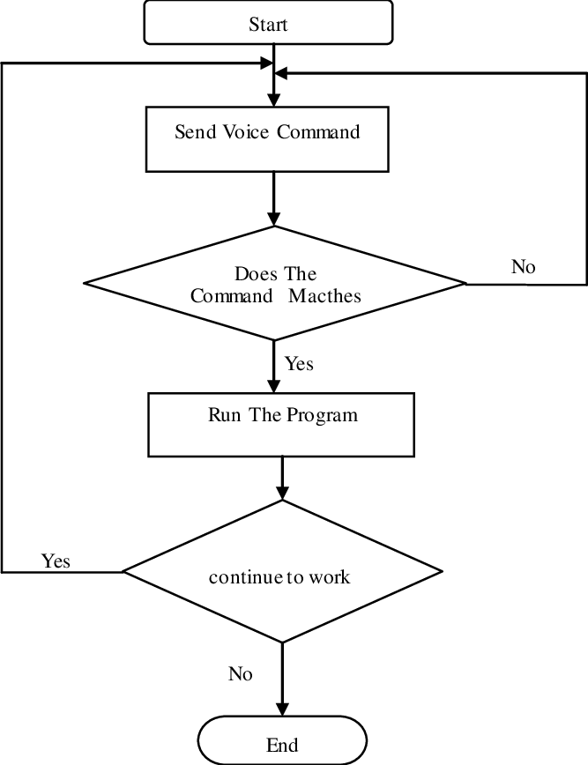

Chapter 4:- TOOLS AND TECHNOLOGIES

These are the necessary tools and materials needed to build the website both the front-end and the back-end. These include software and open source materials.

4.1 Html/Html5:

HTML means Hypertext Markup Language. This language is used in creating web pages. This language also supports other languages such CSS, PHP, JAVASCRIPT, etc. in creating interactive and responsive pages on the pages. HTML5 is just an updated version of the HTML. It supports new features, new attributes, new HTML elements, full CSS3 support, video and audio, 2D/3D graphics that help users and also help web developers to create new features easily on the website.

Fig: The structure of the Html/Html5
4.2 CSS 3

CSS is simply referred to as Cascading Style Sheets.CSS is used to define styles for web pages, including the design, layout, and variations in the display for different de-vices and screen sizes.

The general structure of CSS

Basic syntax:

Selector {property: value}

HTML tag you want to modify

the property you want to change

The value you want the property to take

CSS can be used in a separate style sheet or used in the webpage

Fig: CSS code style
4.3 JAVASCRIPT
Java script is a high-level language which could be used independently or inculcated into the webpage. It can be used to, handle requests and responses and also add dynamic behavior and also store information on a website.

Chapter 5 SOURCE CODE

<html>

<head>
<link rel="stylesheet" type="text/css" href="style.css">
<link href="https://fonts.googleapis.com/css?family=Open+Sans:600,700" rel="stylesheet">
<title>A simple calculator</title>
</head>

<body>
<div id="container">
<div id="calculator">
<div id="result">
<div id="output-text">
<div id="history">
<p id="history-value"></p>
</div>
<div id="output">
<p id="output-value"></p>
</div>
</div>
<div id="output-microphone">
<span id="microphone">
</span>
<span class="tooltip">
Operations are plus, minus, multiply, divide &amp; reminder
The user input format is number + operation + number<br><br>
Eg: 2 multiply 5 will be 2 &times 5
</span>
</div>
</div>
<div id="keyboard">
<button class="operator" id="clear">C</button>
<button class="operator" id="backspace">CE</button>
<button class="operator" id="%">%</button>
<button class="operator" id="/">&#247;</button>
<button class="number" id="1">1</button>
<button class="number" id="2">2</button>
<button class="number" id="3">3</button>
<button class="operator" id="*">&times;</button>
<button class="number" id="4">4</button>
<button class="number" id="5">5</button>
<button class="number" id="6">6</button>
<button class="operator" id="-">-</button>
<button class="number" id="7">7</button>
<button class="number" id="8">8</button>
<button class="number" id="9">9</button>
<button class="operator" id="+">+</button>
<button class="empty" id="empty"></button>
<button class="number big" id="0">0</button>
<button class="empty" id="empty"></button>
<button class="operator" id="=">=</button>
</div>
</div>
</div>
<script src="script.js"></script>
</body>

</html>

body {
font-family: 'Open Sans', sans-serif;
background-color: black;
}

#container {
width: 1000px;
height: 550px;
background-image: linear-gradient(rgba(0, 0, 0, 0.3), rgba(0, 0, 0, 0.3)), url(calsy.jpg);
margin: 20px auto;
}

#calculator {
width: 320px;
height: 520px;
background-color: #eaedef;
margin: 0 auto;
top: 20px;
position: relative;
border-radius: 5px;
box-shadow: 0 4px 8px 0 rgba(0, 0, 0, 0.2), 0 6px 20px 0 rgba(0, 0, 0, 0.19);
}

#result {
height: 120px;
}

#history {
text-align: right;
height: 20px;
margin: 0 20px;
padding-top: 20px;
font-size: 15px;
color: hsl(200, 90%, 49%);
}

#output {
text-align: right;
height: 60px;
margin: 10px 20px;
font-size: 30px;
}

#output-text {
width: 250px;
height: 120px;
float: left;
}

#microphone {
height: 30px;
width: 30px;
float: right;
background-image: url(mic.png);
background-size: 100% 100%;
border-radius: 50%;
margin: 20px;
margin-top: 45px;
animation: microphone-animation 1.5 infinite;
}

.record {
animation: microphone-animation 1.5s infinite;
}

@Keyframes microphone-animation {
0% {
transform: scale(0.9);
}
70% {
transform: scale(1);
box-shadow: 0 0 0 10px rgba(221, 255, 0, 0.4);
}
100% {
transform: scale(0.9);
box-shadow: 0 0 0 0 #39d521c7;
}
}

.tooltip {
width: 200px;
font-size: 9px;
position: absolute;
background-color: #f5114a82;
color: hsl(46, 100%, 62%);
padding: 10px;
top: 45px;
transform: translateX(50px);
border-radius: 5px;
visibility: hidden;
}

.tooltip::before {
content: '';
position: absolute;
border-width: 5px;
border-style: solid;
border-color: transparent hsla(75, 90%, 52%, 0.354) transparent;
left: 0;
margin-left: -10px;
}

#output-microphone:hover .tooltip {
visibility: visible;
}

#keyboard {
height: 400px;
}

.operator,
.number,
.empty {
width: 50px;
height: 50px;
margin: 15px;
float: left;
border-radius: 50%;
border-width: 0;
font-weight: bold;
font-size: 15px;
}

.number,
.empty {
background-color: #0db6ff66;
}

.number,
.operator {
cursor: pointer;
}

.operator:active,
.number:active {
font-size: 13px;
}

.operator:focus,
.number:focus,
.empty:focus {
outline: 0;
}

button:nth-child(4) {
font-size: 20px;
background-color: #dafd3e89;
}

button:nth-child(8) {
font-size: 20px;
background-color: #00ff5e;
}

button:nth-child(12) {
font-size: 20px;
background-color: #f080d8;
}

button:nth-child(16) {
font-size: 20px;
background-color: #94a5e2;
}

button:nth-child(20) {
font-size: 20px;
background-color: #8ac24a;
}

function getHistory() {
return document.getElementById("history-value").innerText;
}

function printHistory(num) {
document.getElementById("history-value").innerText = num;
}

function getOutput() {
return document.getElementById("output-value").innerText;
}

function printOutput(num) {
if (num == "") {
document.getElementById("output-value").innerText = num;
} else {
document.getElementById("output-value").innerText = getFormattedNumber(num);
}
}

function getFormattedNumber(num) {
if (num == "-") {
return "";
}
var n = Number(num);
var value = n.toLocaleString("en");
return value;
}

function reverseNumberFormat(num) {
return Number(num.replace(/,/g, ''));
}
var operator = document.getElementsByClassName("operator");

for (var i = 0; i < operator.length; i++)

{
operator[i].addEventListener('click', function() {
if (this.id == "clear") {
printHistory("");
printOutput("");
} else if (this.id == "backspace") {
var output = reverseNumberFormat(getOutput()).toString();
if (output) { //if output has a value output= output.substr(0,output.length-1);
printOutput(output);
}
} else {
var output = getOutput();
var history = getHistory();
if (output == "" && history != "") {
if (isNaN(history[history.length - 1])) {
history = history.substr(0, history.length - 1);
}
}
if (output != "" || history != "") {
output = output == "" ? output : reverseNumberFormat(output);
history = history + output;
if (this.id == "=") {

var result = eval(history);
printOutput(result);
printHistory("");
} else {
history = history + this.id;
printHistory(history);
printOutput("");
}
}
}
});
}
var number = document.getElementsByClassName("number");
for (var i = 0; i < number.length; i++) {
number[i].addEventListener('click', function() {
var output = reverseNumberFormat(getOutput());
if (output != NaN) { //if output is a number output=output+this.id; printOutput(output);

}
});
}
var microphone = document.getElementById('microphone');
microphone.onclick = function() {
microphone.classList.add("record");
var recognition = new(window.SpeechRecognition || window.webkitSpeechRecognition || window.mozSpeechRecognition || window.msSpeechRecognition)();
recognition.lang = 'en-US';
recognition.start();
operations = {
"plus": "+",
"minus": "-",
"multiply": "",
"multiplied": "",
"divide": "/",
"reminder": "%"
}
recognition.onresult = function(event) {
var input = event.results[0][0].transcript;
for (property in operations) {
input = input.replace(property, operations[property]);
}
document.getElementById("output-value").innerText = input;
setTimeout(function() {
evaluate(input);
}, 2000);
microphone.classList.remove("record");
}
}

function evaluate(input) {
try {
var result = eval(input);
document.getElementById("output-value").innerText = result;
} catch (e) {
console.log(e);
document.getElementById("output-value").innerText = "";
}
}

Chapter 6 SCREEN SHOTS
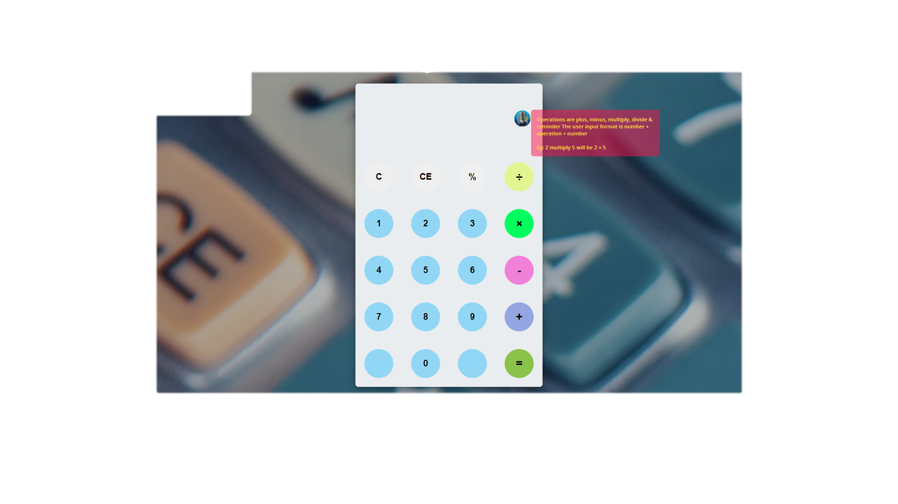Fig: page view of Calculator

If we click the microphone it will ask you to permit the allow button to speak
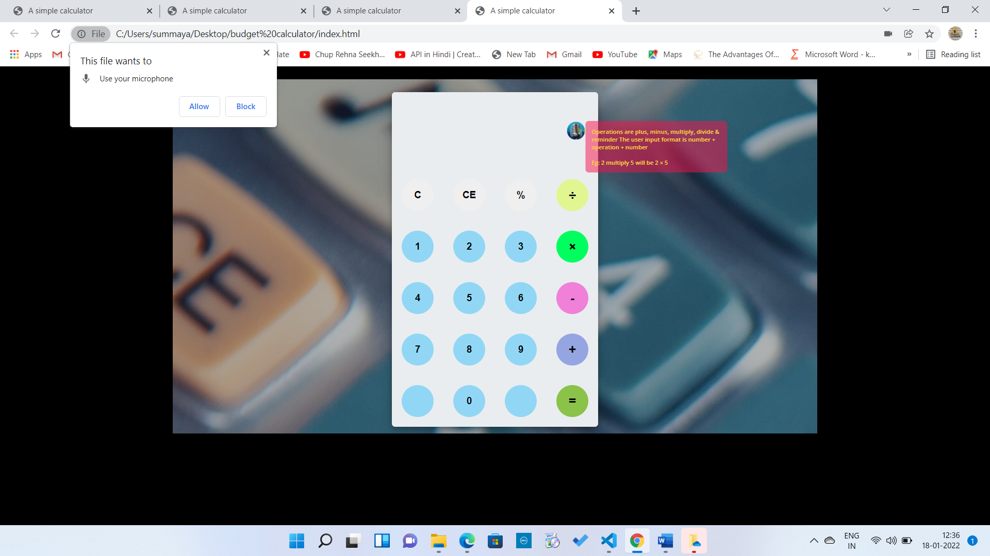
fig: Allowing microphone in Calculator
We can do the calculation by just single click on microphone
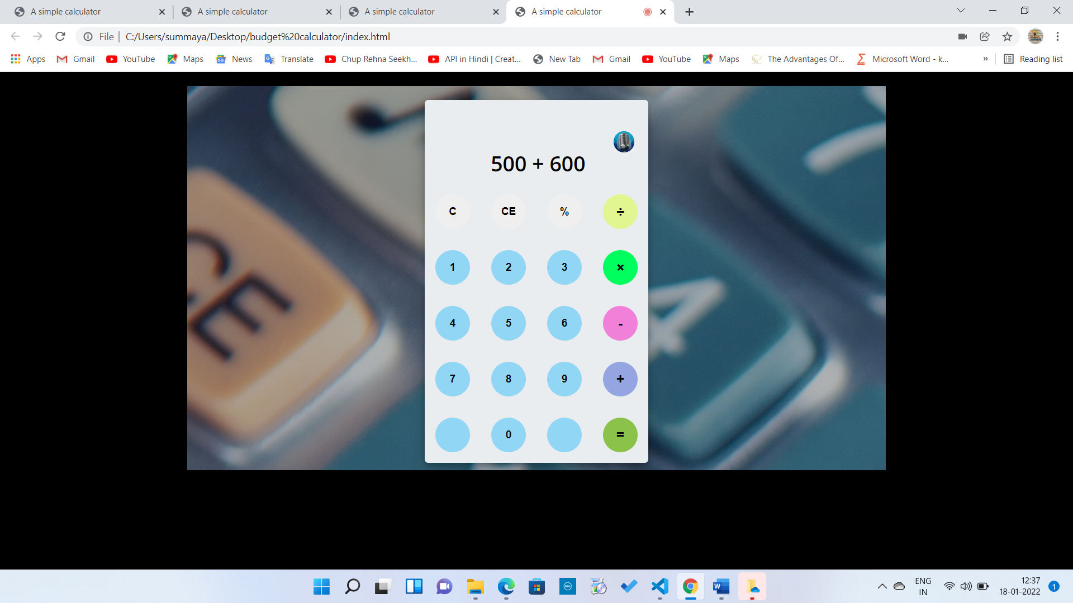
Fig: Apply some Calculation in calculator

Conclusion will display automatically
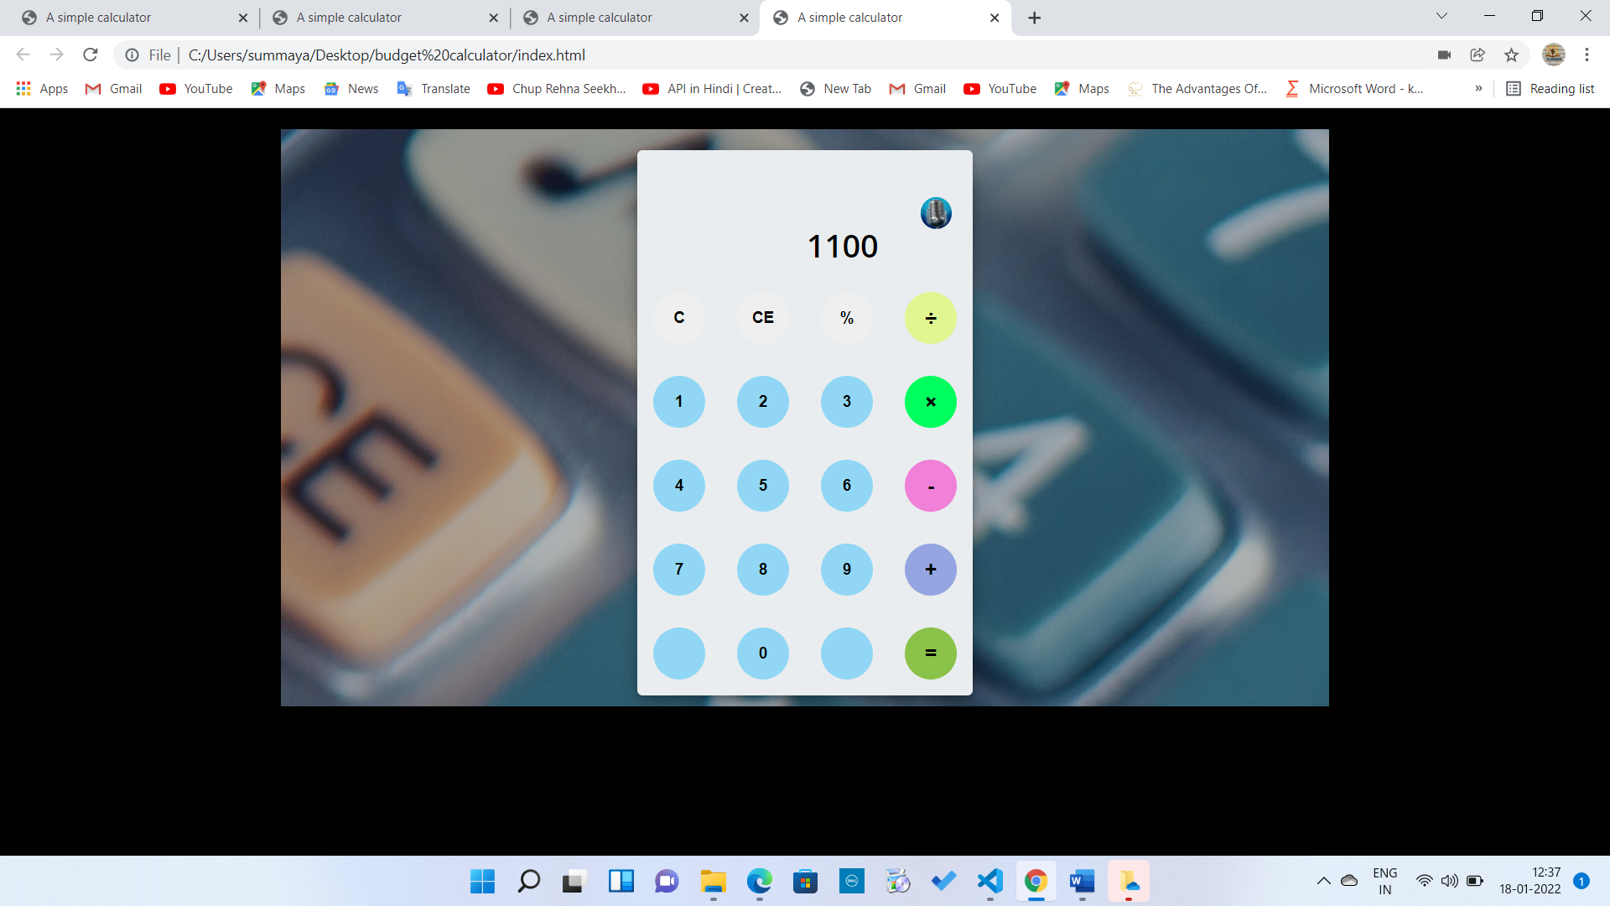
Fig: Conclusion view
Fig: Voice recognition Calculator View
Chapter 7 CONCLUSION

It is quite clear that there is still very long way to go before text-to-speech synthesis, especially high-level synthesis, is fully acceptable. However, the development is going forward steadily and in the long run the technology seems to make progress faster than we can imagine. Thus, when developing a speech synthesis system, we may use almost all resources available, because in few years todays high resources are available in every personal computer. Regardless how fast the development process will be, speech synthesis, whenever used in low-cost calculators or state-of-the-art multimedia solutions, has probably the most promising future. If speech recognition systems someday achieve a generally acceptable level, we may develop for example a communication system where the system may first analyze the speakers' voice and its characteristics, transmit only the character string with some control symbols, and finally synthesize the speech with individual sounding voice at the other end. Even interpretation from a language to another may became feasible. Speech recognition allows calculations to be done faster because the software generally produces words as quickly as they uttered, which is usually much faster than a person can type

SUMMAYA EREEZA – 245219733020
KAVALI SRAVANI - 245219733009
KONNE RAMYA -245219733305

END OF THE PROJECT

